**School of Computer Science**

**UNIVERSITY OF PETROLEUM AND ENERGY STUDIES**

**DEHRADUN, UTTARAKHAND**



**Subject Name**

**Lab File**

**(2023-2024)**

**for**

**5th Semester**

|  |  |
| --- | --- |
| Submitted To:  Dr. Hitesh Kumar Sharma | Submitted By:  Avni Chauhan  500093047  B2 |

Lab Exercise 4– Terraform Variables

# Objective:

Learn how to define and use variables in Terraform configuration.

# Prerequisites:

* Install Terraform on your machine.

# Steps:

1. **Create a Terraform Directory:**
   * Create a new directory for your Terraform project.

**mkdir terraform-variables cd terraform-variables**

# Create a Terraform Configuration File:

* + Create a file named main.tf within your project directory.

**# main.tf**

provider "aws" {

    region = "us-west-2"

    }

resource "aws_instance" "example" {

    ami = "ami-03f4878755434977f"

     instance_type = "t2.micro"

     }

     provider "aws" {

        region = var.region

}

resource "aws_instance" "example" {

    ami = var.ami

instance_type = var.instance_type

}

# Define Variables:

* + Open a new file named variables.tf. Define variables for region, ami, and instance_type.

**# variables.tf**

variable "region" {

    description = "AWS region"

    default    = "us-west-2"

    }

variable "ami" {

     description = "AMI ID"

type = string

default   = "ami-03f4878755434977f"

}

variable "instance_type" {

     description = "EC2 Instance Type"

      default  = "t2.micro"

}

# Use Variables in main.tf:

* + Modify main.tf to use the variables.

**# main.tf**

resource "aws_instance" "example" {

    ami = var.ami

instance_type = var.instance_type

}

# Initialize and Apply:

* + Run the following Terraform commands to initialize and apply the configuration.

**terraform apply**

Observe how the region changes based on the variable override.

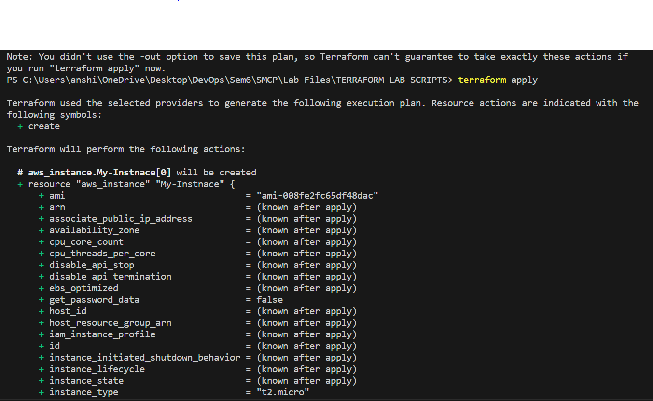

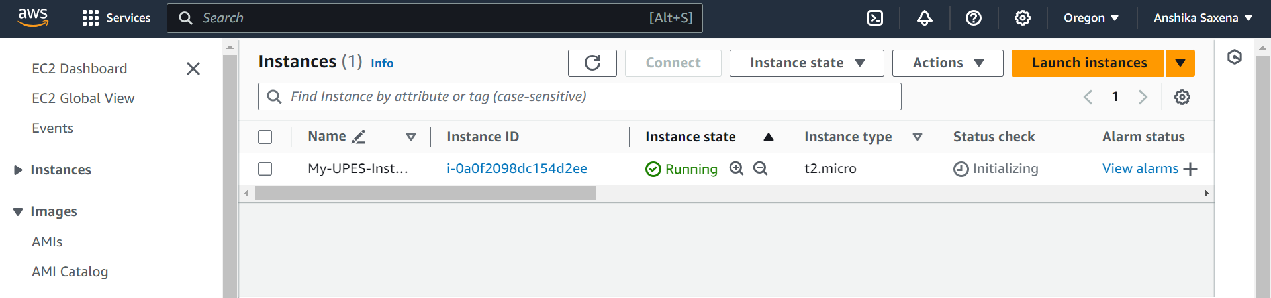

# Clean Up:

After testing, you can clean up resources.

**terraform destroy**

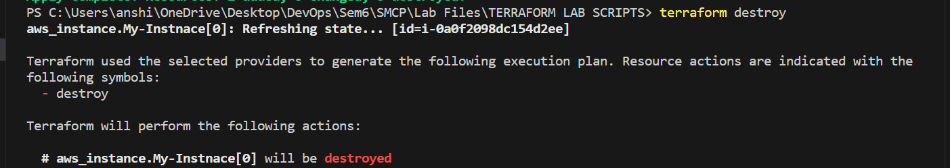

Confirm the destruction by typing yes.

